SQL Assignments - Set 4

- Display the employee names and department names of all the employees working in the job type Salesman as well as Analyst
Select e.Ename,
d.DeptNo,
e.Job
From Emp e Join Dept d
On e.Deptno = d.Deptno
Where e.Job = 'Analyst' Or e.Job = 'Salesman';

- Display the following report.

ENAME DEPARTMENT NAME
---------- ------------------------------
SMITH SMITH works in RESEARCH
ALLEN ALLEN works in SALES
WARD WARD works in SALES
JONES JONES works in RESEARCH
MARTIN MARTIN works in SALES
BLAKE BLAKE works in SALES
CLARK CLARK works in ACCOUNTING
SCOTT SCOTT works in RESEARCH
KING KING works in ACCOUNTING
TURNER TURNER works in SALES
ADAMS ADAMS works in RESEARCH
JAMES JAMES works in SALES
FORD FORD works in RESEARCH
MILLER MILLER works in ACCOUNTING

Select e.Ename as "ENAME",
Concat( Upper(e.Ename) , " works in " , d.Dname) As "DEPARTMENT NAME"
From Emp e Join Dept d
On e.DeptNo = D.DeptNo;

- Display the highest salary for each job within each department as per the following report –

Department JOB Highest Sal
-------------- --------- -------------------------------------
ACCOUNTING CLERK 1300
ACCOUNTING MANAGER 2450
ACCOUNTING PRESIDENT 5000
RESEARCH ANALYST 3000
RESEARCH CLERK 1100
RESEARCH MANAGER 2975
SALES CLERK 950
SALES MANAGER 2850
SALES SALESMAN 1600

9 rows selected.

Select d.DName as "Department",
e.Job,
Max(e.Sal) as "Highest Sal"
From Emp e Join Dept d
On e.DeptNo = d.DeptNo
Group By d.dname,e.Job
Order By d.Dname;

4. Display employee name, department name, location and job for all employees of MANAGER job having salary above 2900.

Select e.Ename,
d.Dname,
d.Loc,
e.Job
From Emp e Join Dept d
On e.DeptNo = d.DeptNo
Where E.Job = 'MANAGER'
And
E.Sal > 2900;

- Display the name of the employees reporting to KING.

Select e1.Ename
From Emp e Join Emp e1
On e.Empno = e1.Mgr
Where e.EName = 'KING';

- Display the count of employees reporting to KING.

Select count(e1.mgr) as "Count"
From Emp e Join Emp e1
On e.Empno = e1.Mgr
Where e1.Mgr = e.Empno
And
e.EName = 'KING';

- Produce the following output –

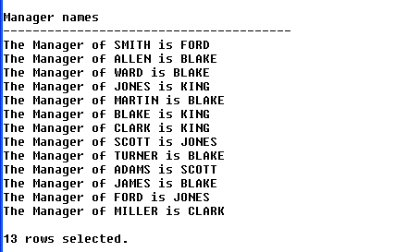

Select Concat( "The Manager of ", m.Ename, " is ", e.Ename) As "Manager Names"
From Emp e Join Emp m
On m.Mgr = e.EmpNo;

Copy-Paste the following script about Flight Schedule in your schema –

create table customers(CustId int Primary Key, CustName varchar(40), FlightNo int Not Null);

create table flights(FlightNo int Primary key, GateNo char(3) Not Null, FlightName varchar(40), Status varchar(100), Route Varchar(100));

Insert Into Customers Values(1,'a',123);
Insert Into Customers Values(2,'b',456);
Insert Into Customers Values(3,'c',123);
Insert Into Customers Values(4, 'd',456);
Insert Into Customers Values(5, 'e', 789);
Insert Into Customers Values(6, 'f', 123);
Insert Into Customers Values(7, 'g', 456);
Insert Into Customers Values(8, 'h', 789);
Insert Into Customers Values(9, 'i', 456);
Insert Into Customers Values(10, 'j', 123);
Insert Into Customers Values(11, 'k', 125);
Insert Into Customers Values(12, 'l', 456);
Insert Into Customers Values(13, 'm', 789);
Insert Into Customers Values(14, 'n', 124);
Insert Into Customers Values(15, 'o', 125);
Insert Into Customers Values(16, 'p', 126);
Insert Into Customers Values(17, 'q', 125);
Insert Into Customers Values(18, 'r', 126);
Insert Into Customers Values(19, 's', 127);
Insert Into Customers Values(20, 't', 127);

Insert Into Flights Values('123', 'G1', 'Spice Jet', 'Departure On Time', 'Pune-Delhi');
Insert Into Flights Values('456', 'G2', 'Indigo', 'Departure Late by 45 Minutes', 'Pune-Hyderabad');
Insert Into Flights Values('789', 'G1', 'Jet Lite', 'Departed', 'Pune-Bangalore');
Insert Into Flights Values('124', 'G3', 'Indian Airlines', 'Arrival late by 30 Minutes', 'Chennai-Pune-Baroda');
Insert Into Flights Values('125', 'G4', 'King Fisher', 'Departure On Time', 'Pune-Kolkata');
Insert Into Flights Values('126', 'G7', 'King Fisher', 'Departure On Time', 'Pune-Chandigad');
Insert Into Flights Values('127', 'G9', 'Air Deccan', 'Departure On Time', 'Pune-Chandigad');

- Display the names of the customers who are going to depart on time.

Select c.CustName
From Customers c Join Flights f
On f.FlightNo = c.FlightNo
Where f.Status = "Departure On Time";

- Display the names of those customers who are not flying from Pune to Bangalore

Select c.CustName
From Customers c Join Flights f
On f.FlightNo = c.FlightNo
Where f.route <> 'Pune-Bangalore';

- Display the names of those customers who all are going from Gate number 1.

Select c.CustName
From Customers c Join Flights f
On f.FlightNo = c.FlightNo
Where f.GateNo='G1';

- Display the names of those customers who are going to Chandigad through King Fisher airlines only.

Select c.CustName
From Customers c Join Flights f
On f.FlightNo = c.FlightNo
Where f.Route = 'Pune-Chandigad'
And
f.FlightName = 'King Fisher';

Copy-Paste the following script about Billing Cycle in your schema –

create table Customer_Details
(CustId Char(3), CName Varchar(20));

create table Payment_Details
(CustId Char(3), PaymentId char(3), Amount Int, Status varchar(20));

Insert Into Customer_Details Values('C1', 'John');
Insert Into Customer_Details Values('C2','Roger');
Insert Into Customer_Details Values('C3','Smith');
Insert Into Customer_Details Values('C4','Martin');
Insert Into Customer_Details Values('C5','Luther');
Insert Into Customer_Details Values('C6', 'King');
Insert Into Customer_Details Values('C7','Allen');

Insert Into Payment_Details Values('C1', 'P1', 35000, 'Paid');
Insert Into Payment_Details Values('C3','P2',80000,'Paid');
Insert Into Payment_Details Values('C16','P3',90000,Null);
Insert Into Payment_Details Values('C6','P4',10000,'Paid');

- Generate the following report –

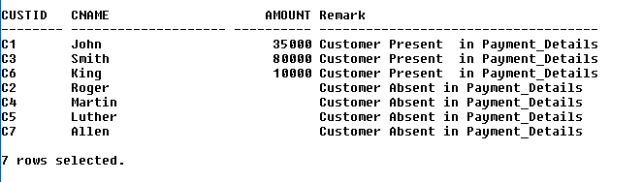

Select cd.CustId,
cd.Cname,
pd.Amount,
Case
When pd.Status = "Paid"
Then "Customer Present in Payment_Details"
Else
"Customer Absent in Payment_Details"
End As "Remark"
From Customer_Details cd Left Join Payment_Details pd
On cd.CustId = pd.CustId
Order By pd.Status Desc;

- Display the customer id customer name, status and amount of the customers who have paid as well as those who have not paid.

Select cd.CustID,
cd.Cname,
pd.Status,
pd.Amount
From Customer_Details cd Left Join Payment_Details pd
On cd.CustId = pd.CustId;

Create the following 3 tables and insert the records in each table by copy pasting the below SQL script.

create table continent_master
(ContinentID Varchar(15),
Name_of_Continent Varchar(20),
Continent_Amount_Allocated Int
);

create table country_master
(ContinentID Varchar(15),
CountryID Varchar(15),
Name_of_Country Varchar(50),
Country_Amount_Allocated Int
);

create table transactions
(TrID Varchar(10),
CountryID Varchar(15),
Name_of_City Varchar(40),
Amount_Spent Int
);

Insert into continent_master values('Con1', 'Asia', 50000);
Insert into continent_master values('Con2', 'Africa', 30000);
Insert into continent_master values('Con3', 'Europe', 80000);
Insert into continent_master values('Con4', 'Australia', 85000);
Insert into continent_master values('Con5', 'Americas', 90000);
Insert into country_master values('Con1','Cu1','India',10000);
Insert into country_master values('Con1','Cu2','China',20000);
Insert into country_master values('Con1','Cu3','UAE',15000);
Insert into country_master values('Con2','Cu4','Sudan',15000);
Insert into country_master values('Con2','Cu5','Kenya',15000);
Insert into country_master values('Con3','Cu6','France',20000);
Insert into country_master values('Con3','Cu7','Germany',20000);
Insert into country_master values('Con3','Cu8','Italy',20000);
Insert into country_master values('Con4','Cu9','Australia', 12000);
Insert into country_master values('Con4','Cu10','New Zealand', 9000);
Insert into country_master values('Con5','Cu11','USA', 50000);
Insert into country_master values('Con5','Cu12','Canada', 35000);
Insert into country_master values('Con5','Cu13','Brazil', 20000);
Insert into country_master values('Con5','Cu14','Argentina', 15000);
Insert into Transactions values('T1', 'Cu1','Mumbai',200);
Insert into Transactions values('T2', 'Cu1','Mumbai',150);
Insert into Transactions values('T3', 'Cu1','Delhi',50);
Insert into Transactions values('T4', 'Cu1','Delhi',70);
Insert into Transactions values('T5','Cu2','Beijing',300);
Insert into Transactions values('T6','Cu2','Beijing',200);
Insert into Transactions values('T7','Cu2','Shanghai',700);
Insert into Transactions values('T8','Cu2','Shanghai',900);
Insert into Transactions values('T9','Cu3','Dubai',1000);
Insert into Transactions values('T10','Cu3','Dubai',1500);
Insert into Transactions values('T11', 'Cu3','Abu Dhabi',800);
Insert into Transactions values('T12', 'Cu3','Abu Dhabi',600);
Insert into Transactions values('T13','Cu4','Khartoum',80);
Insert into Transactions values('T14','Cu4','Khartoum',20);
Insert into Transactions values('T15','Cu4','Kassala',50);
Insert into Transactions values('T16','Cu4','Kassala',10);
Insert into Transactions values('T17','Cu5','Nairobi',90);
Insert into Transactions values('T18','Cu5','Nairobi',70);
Insert into Transactions values('T19','Cu5','Mombasa', 300);
Insert into Transactions values('T20','Cu5','Mombasa', 2000);
Insert into Transactions values('T21','Cu6','Paris', 900);
Insert into Transactions values('T22','Cu6','Paris', 1100);
Insert into Transactions values('T23','Cu6','Lyon', 2100);
Insert into Transactions values('T24','Cu6','Lyon', 200);
Insert into Transactions values('T25','Cu7','Berlin', 500);
Insert into Transactions values('T26','Cu7','Berlin', 700);
Insert into Transactions values('T27','Cu7','Munich', 1500);
Insert into Transactions values('T28','Cu7','Munich', 1700);
Insert into Transactions values('T29','Cu8','Rome', 3000);
Insert into Transactions values('T30','Cu8','Rome', 2000);
Insert into Transactions values('T31','Cu8','Milan', 500);
Insert into Transactions values('T32','Cu8','Milan', 800);
Insert into Transactions values('T33','Cu9','Sydney', 2800);
Insert into Transactions values('T34','Cu9','Sydney', 3100);
Insert into Transactions values('T35','Cu9','Melbourne', 1400);
Insert into Transactions values('T36','Cu9','Melbourne', 2400);
Insert into Transactions values('T37','Cu10','Auckland', 600);
Insert into Transactions values('T38','Cu10','Auckland', 800);
Insert into Transactions values('T39','Cu10','Wellington', 2100);
Insert into Transactions values('T40','Cu10','Wellington', 2700);
Insert into Transactions values('T41','Cu11','Sand City', 5000);
Insert into Transactions values('T42','Cu11','Sand City', 6000);
Insert into Transactions values('T43','Cu11','Dublin', 2000);
Insert into Transactions values('T44','Cu11','Dublin', 1000);
Insert into Transactions values('T45','Cu12','Toronto', 2200);
Insert into Transactions values('T46','Cu12','Toronto', 3300);
Insert into Transactions values('T47','Cu12','Ottawa', 2100);
Insert into Transactions values('T48','Cu12','Ottawa', 1300);
Insert into Transactions values('T49','Cu13','Sao Paulo', 900);
Insert into Transactions values('T50','Cu13','Sao Paulo', 400);
Insert into Transactions values('T51','Cu13','Rio de Janeiro', 700);
Insert into Transactions values('T52','Cu13','Rio de Janeiro', 800);
Insert into Transactions values('T53','Cu14','Buenos Aires', 200);
Insert into Transactions values('T54','Cu14','Buenos Aires', 400);
Insert into Transactions values('T55','Cu14','Rosario', 2300);
Insert into Transactions values('T56','Cu14','Rosario', 4400);

ERD:
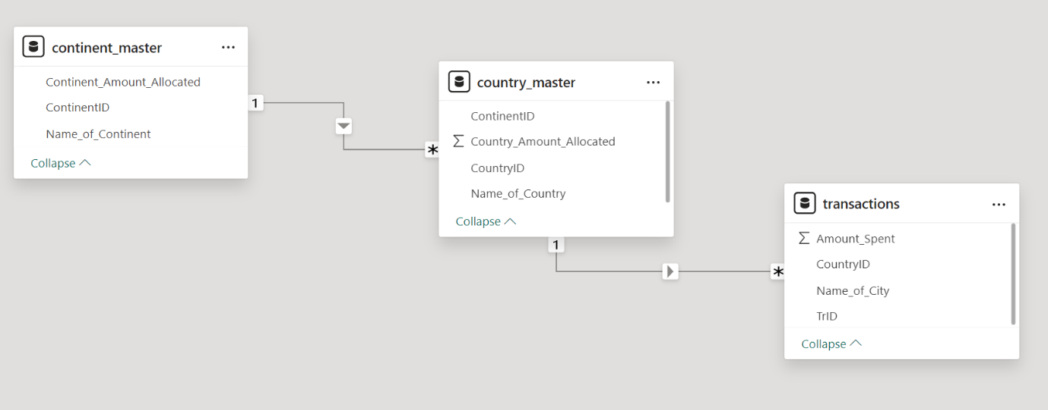

- Display transaction id, continent name, country name, city name, amount allocated and amount spent.

Select trans.TrID,
cont.Name_of_Continent,
coun.Name_of_Country,
trans.Name_of_City,
coun.Country_Amount_Allocated,
trans.Amount_Spent
From Country_Master Coun join Continent_Master cont
On Coun.ContinentID = cont.ContinentID
Join Transactions trans
on trans.CountryId = Coun.CountryID;

- Display the total amount spent for each city, within each country from each continent.

Select cont.Name_of_Continent,
coun.Name_of_Country,
trans.Name_of_City,
Sum(trans.Amount_Spent) as "Total Amount Spent"
From Country_Master Coun join Continent_Master cont
On Coun.ContinentID = cont.ContinentID
Join Transactions trans
on trans.CountryId = Coun.CountryID
Group By cont.Name_of_Continent, coun.Name_of_Country, trans.Name_of_City;

